**Data Model**

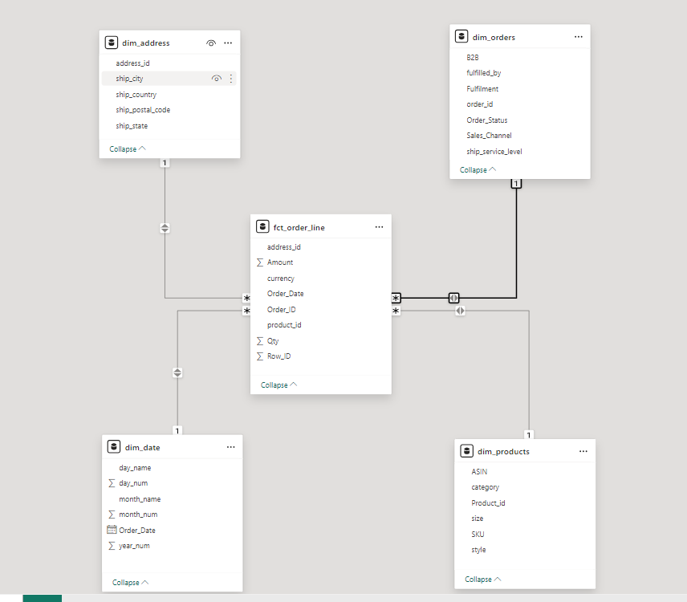

1. 4 dimensioanal tables –
   1. dim_orders with order_id as primary key
   2. dim_products with product_id (combination of ASIN and SKU) as primary key
   3. dim_date with order_date as primary key
   4. dim_address with address_key(combination of city, state, country and zip code) as primary key
2. Fct_sales_order fact table with –
   1. row_id as primary key
   2. foreign keys order_id to reference dim_orders.order_id
   3. foreign keys product _id to reference dim_products.product_id
   4. foreign keys address_id to reference dim_address.address_id
   5. foreign keys order_date to reference dim_date.order_date

**dbt outputs**

**dbt run output**

1. stg_amazon_sales_report_vw view is created from raw data table in sales_dl schema
2. 4 dimensioanal tables - dim_orders, dim_products, dim_date, dim_address are created in sales_dl_dwh schema
3. 1 fact table - fct_order_line is created in sales_dl_dwh schema

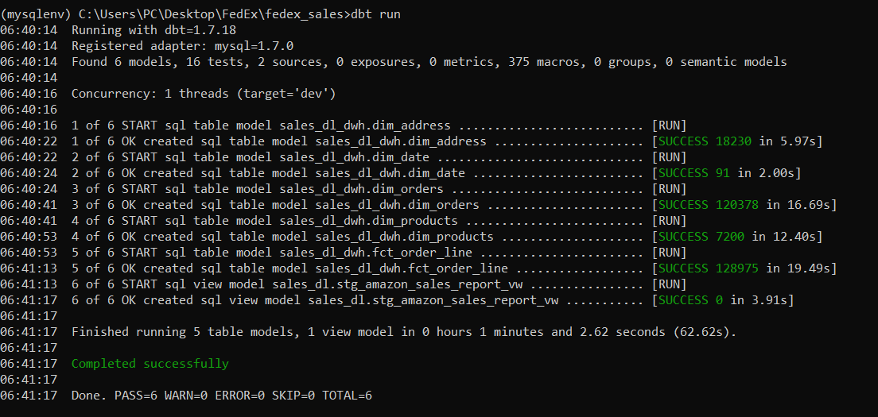

**dbt test output**

1. All tables have primary key test case
2. Fact table fct_order_line has foreign key test cases to refer primary key of corresponding dimensional table.

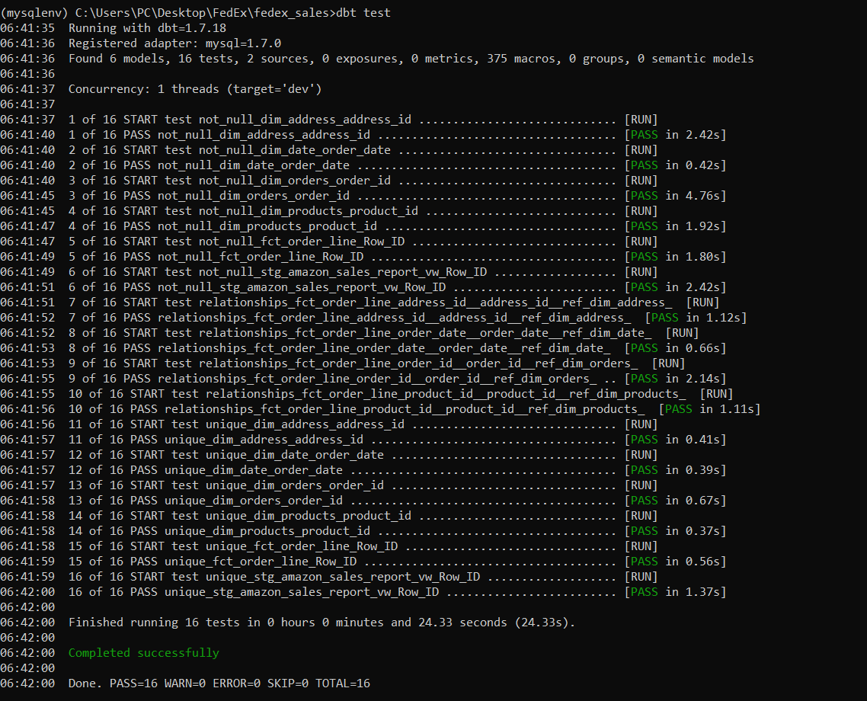

**dbt docs generated**

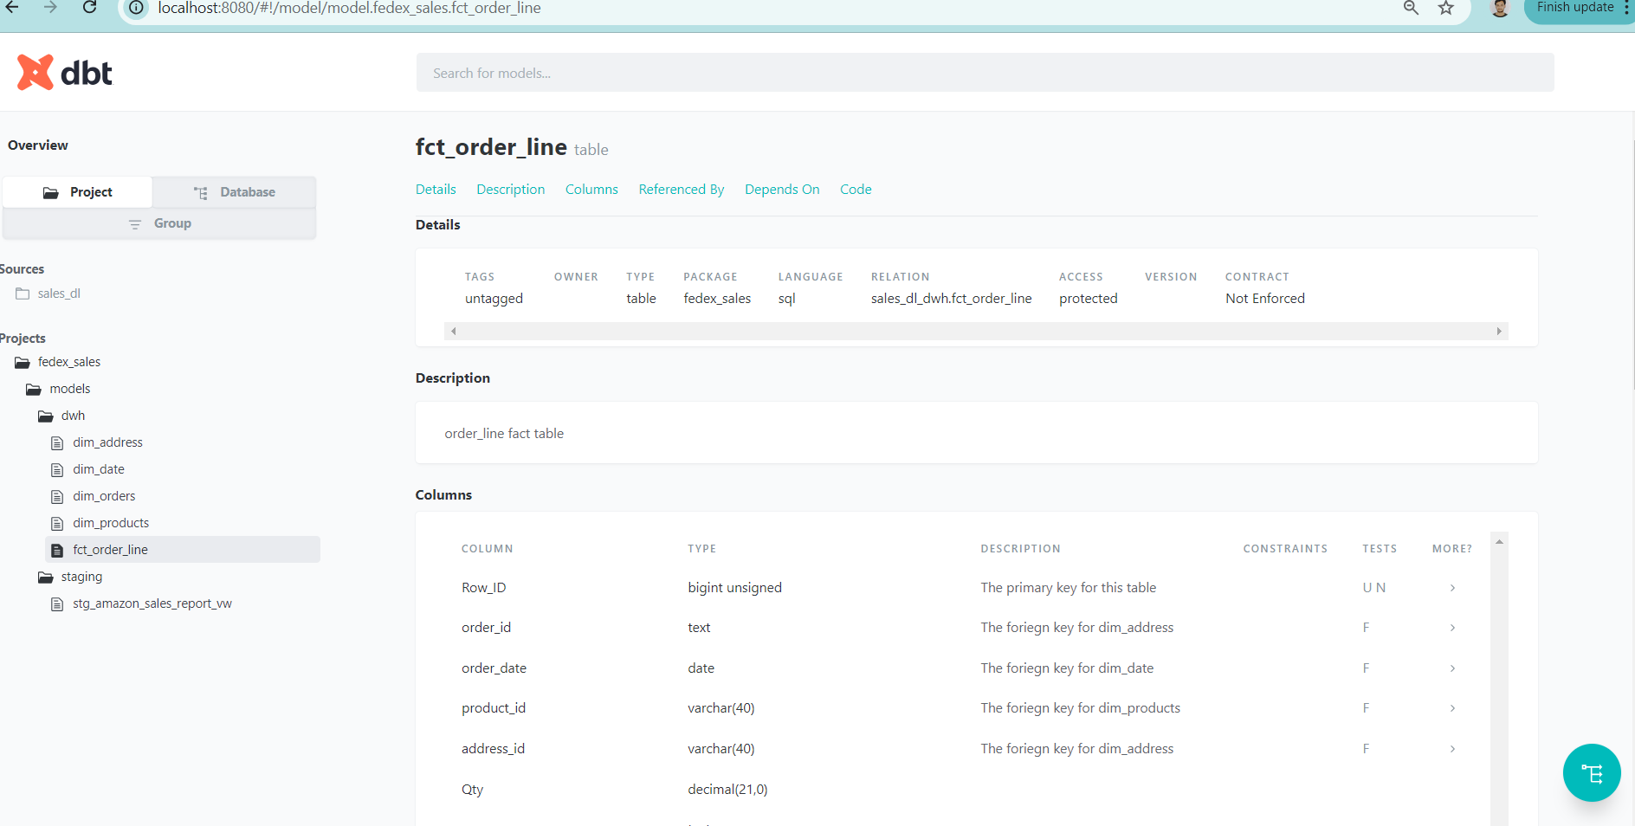

**Data Lineage graph generated by dbt**

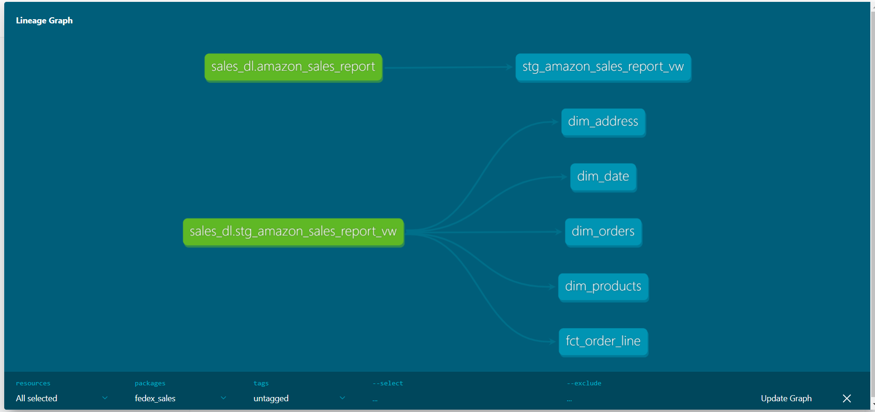

**Power BI Visualizations**

